AI POWERED CROP YIELD PREDICTION AND OPTIMIZATION
A MINI PROJECT REPORT
Submitted in partial fulfilment of the requirements
for the award of the degree of
BACHELOR OF TECHNOLOGY
in
COMPUTER SCIENCE AND BUSINESS SYSTEMS
Submitted by
G. PREETHI
Register No: 922525244040
[ COLLEGE / INSTITUTION NAME ]
[ Affiliated to ... University ]
DEPARTMENT OF COMPUTER SCIENCE AND BUSINESS SYSTEMS
2025 - 2026

BONAFIDE CERTIFICATE
This is to certify that the mini project report titled "AI POWERED CROP YIELD PREDICTION AND OPTIMIZATION" is a bonafide record of work done by G. PREETHI (Register No: 922525244040) of the Department of Computer Science and Business Systems (CSBS), in partial fulfilment of the requirements for the award of the degree of Bachelor of Technology in Computer Science and Business Systems during the academic year 2025-2026.
The report has been prepared under my/our supervision and represents the independent work of the candidate. It has not been submitted, in part or in full, to any other university or institution for the award of any degree or diploma.
Signature of Guide Signature of Head of Department
Name: ____________________________ Name: ____________________________
Designation: _______________________ Department: CSBS
Submitted for the Mini Project Viva-Voce Examination held on ______________
Internal Examiner External Examiner

DECLARATION
I, G. PREETHI, bearing Register Number 922525244040, hereby declare that the mini project report entitled "AI POWERED CROP YIELD PREDICTION AND OPTIMIZATION" submitted by me to the Department of Computer Science and Business Systems is a record of bonafide work carried out by me under the guidance of my project supervisor.
I further declare that this report, or any part thereof, has not been submitted elsewhere for the award of any degree, diploma, or similar title, and that all sources of information used in the preparation of this report have been duly acknowledged.
Place: ____________________
Date: ____________________
(G. PREETHI)
Reg. No: 922525244040

ACKNOWLEDGEMENT
I would like to express my sincere gratitude to everyone who supported and guided me throughout the course of this mini project.
I am deeply thankful to my project guide for their invaluable guidance, constant encouragement, and constructive feedback at every stage of this project, which helped me shape this work into its present form.
I extend my heartfelt thanks to the Head of the Department, Computer Science and Business Systems, and to the Principal of the institution for providing the necessary facilities and a conducive environment for carrying out this project.
I am also grateful to all the faculty members of the Department of CSBS for their support and for sharing their knowledge, which enriched my understanding of the subject.
Finally, I would like to thank my family and friends for their constant motivation, patience, and support, without which the completion of this project would not have been possible.
(G. PREETHI)

ABSTRACT
Agriculture continues to be the backbone of food security and rural livelihood in many parts of the world, yet crop yields remain highly vulnerable to unpredictable weather patterns, soil degradation, inefficient resource utilisation, and limited access to data-driven decision support. Traditional yield estimation methods rely heavily on manual surveys, historical averages, and farmer experience, which often fail to capture the complex, non-linear interactions between soil, climate, and management practices that determine actual crop output. This mini project, titled "AI Powered Crop Yield Prediction and Optimization," proposes an intelligent system that leverages machine learning and data analytics to predict crop yield with high accuracy and to recommend optimal agronomic practices that can improve productivity while conserving resources.
The system integrates multiple heterogeneous data sources, including historical yield records, soil nutrient and pH measurements, weather parameters such as rainfall, temperature and humidity, and satellite-derived vegetation indices, into a unified feature set. This data is cleaned, normalised, and engineered into meaningful predictors before being used to train and compare several machine learning models, namely Linear Regression, Decision Tree, Random Forest, XGBoost, and a Long Short-Term Memory (LSTM) neural network for capturing temporal weather trends. Among these, the ensemble-based XGBoost model achieved the best performance, with an R² score of approximately 0.93 and a low root mean squared error, demonstrating strong predictive capability on unseen test data.
Beyond prediction, the project introduces an optimization module that uses the trained model in conjunction with a search-based recommendation strategy to suggest adjustments to controllable inputs, such as fertilizer dosage, irrigation frequency, and sowing date, that are estimated to maximise yield under given environmental constraints. The complete solution is exposed through a simple web-based dashboard that allows a farmer or agricultural officer to enter field-specific parameters and instantly view the predicted yield along with actionable recommendations.
The results of this study indicate that machine learning based decision support systems can meaningfully augment traditional agricultural practices by providing timely, data-driven insights at low cost. The project also discusses the limitations of the current approach, including data availability and generalisation across diverse agro-climatic zones, and outlines directions for future work such as integration of real-time IoT sensor feeds, drone-based imagery, and reinforcement learning for continuous optimisation.
Keywords: Crop Yield Prediction, Machine Learning, Precision Agriculture, XGBoost, Random Forest, LSTM, Yield Optimization, Decision Support System, Smart Farming.

TABLE OF CONTENTS
CHAPTER 1 12
INTRODUCTION 12
1.1 Background 12
1.2 Motivation 13
1.3 Problem Statement 13
1.4 Objectives of the Project 14
1.5 Scope of the Project 14
1.6 Organization of the Report 14
CHAPTER 2 16
LITERATURE SURVEY 16
2.1 Introduction 16
2.2 Statistical and Classical Machine Learning Approaches 16
2.3 Deep Learning Based Approaches 16
2.4 Remote Sensing and IoT Driven Methods 17
2.5 Optimization and Decision Support Systems 17
2.6 Summary of Literature Survey 18
2.7 Research Gap 18
CHAPTER 3 19
SYSTEM ANALYSIS 19
3.1 Existing System 19
3.2 Limitations of the Existing System 19
3.3 Proposed System 20
3.4 Feasibility Study 20
3.4.1 Technical Feasibility 20
3.4.2 Economic Feasibility 20
3.4.3 Operational Feasibility 21
3.4.4 Schedule Feasibility 21
CHAPTER 4 22
SYSTEM REQUIREMENTS 22
4.1 Functional Requirements 22
4.2 Non-Functional Requirements 22
4.3 Hardware Requirements 23
4.4 Software Requirements 23
CHAPTER 5 24
SYSTEM DESIGN 24
5.1 System Architecture 24
5.2 Data Flow Diagrams 25
5.3 Use Case Diagram 26
5.4 Module Description 27
5.4.1 Data Acquisition Module 27
5.4.2 Preprocessing and Feature Engineering Module 27
5.4.3 Model Training and Evaluation Module 27
5.4.4 Prediction Module 27
5.4.5 Optimization Module 28
5.4.6 Presentation / Dashboard Module 28
5.5 Database / Data Store Design 28
5.6 Design Considerations 28
CHAPTER 6 30
METHODOLOGY AND IMPLEMENTATION 30
6.1 Overview of the Methodology 30
6.2 Dataset Description 30
6.3 Data Preprocessing 31
6.4 Feature Engineering 31
6.5 Model Training and Selection 32
6.5.1 Linear Regression 32
6.5.2 Decision Tree Regressor 33
6.5.3 Random Forest Regressor 33
6.5.4 XGBoost Regressor 33
6.5.5 LSTM Neural Network 33
6.6 Optimization Module 33
6.7 System Implementation 35
6.7.1 Technology Stack 35
6.7.2 Model Training Pipeline (Sample Code) 35
6.7.3 Web Dashboard Integration 36
6.8 Development Methodology 36
CHAPTER 7 37
TESTING 37
7.1 Testing Objectives 37
7.2 Levels of Testing 37
7.2.1 Unit Testing 37
7.2.2 Integration Testing 37
7.2.3 System Testing 37
7.2.4 User Acceptance Testing 37
7.3 Test Case Design 38
7.4 Validation of Model Predictions 38
7.5 Summary of Testing Outcomes 39
CHAPTER 8 40
RESULTS AND DISCUSSION 40
8.1 Model Performance Comparison 40
8.2 Actual vs Predicted Yield Analysis 41
8.3 Effectiveness of the Optimization Module 42
8.4 Discussion 42
CHAPTER 9 43
CONCLUSION AND FUTURE SCOPE 43
9.1 Conclusion 43
9.2 Limitations 43
9.3 Future Scope 44
REFERENCES 45
APPENDIX A 46
SAMPLE SOURCE CODE 46
A.1 Data Preprocessing and Feature Engineering 46
A.2 Flask API for Prediction and Optimization Endpoints 46
A.3 LSTM Model Definition (Keras) 47

LIST OF FIGURES
Fig 5.1 Proposed System Architecture
Fig 5.2 Data Flow Diagram - Level 0
Fig 5.3 Data Flow Diagram - Level 1
Fig 5.4 Use Case Diagram
Fig 6.1 Feature Importance Ranking (Random Forest)
Fig 8.1 Performance Comparison of ML Models on Test Dataset
Fig 8.2 Actual vs Predicted Crop Yield (XGBoost Model)
LIST OF TABLES
Table 2.1 Summary of Literature Survey
Table 4.1 Hardware Requirements
Table 4.2 Software Requirements
Table 6.1 Dataset Attribute Description
Table 7.1 Sample Test Cases
Table 8.1 Model Performance Comparison

CHAPTER 1

INTRODUCTION

1.1 Background
Agriculture is one of the oldest and most essential human activities, providing food, raw materials, and livelihoods to a large fraction of the global population. In countries with agrarian economies, crop production directly influences food security, rural income, and national GDP. However, the productivity of agricultural land is influenced by a complex web of interacting factors including soil fertility, weather conditions, water availability, pest and disease pressure, and the timeliness and quality of farm management decisions such as sowing date, fertilizer application, and irrigation scheduling.
Historically, farmers have relied on generational knowledge, empirical observation, and simple statistical averages to estimate expected yield and to plan the coming season. While such experience-based approaches have served agricultural communities for centuries, they struggle to keep pace with the increasing variability introduced by climate change, changing soil health, and the growing complexity of modern input markets. Under-prediction of yield can lead to inadequate planning of storage, transport, and market linkages, while over-prediction can result in food shortages and price volatility.
The last decade has witnessed rapid growth in the availability of agricultural data, ranging from government-maintained historical yield and rainfall records to satellite-derived vegetation indices and low-cost soil sensors. Simultaneously, advances in machine learning have produced algorithms that are capable of learning complex, non-linear relationships between many input variables and an outcome of interest. The convergence of these two trends -- growing data availability and maturing predictive algorithms -- has created a strong opportunity to build intelligent, data-driven decision support tools for agriculture, commonly referred to under the umbrella term "precision agriculture" or "smart farming."
This mini project explores this opportunity by designing and implementing an AI-powered system that predicts crop yield from a combination of soil, weather, and historical data, and further recommends optimized input parameters that are likely to improve the predicted yield. The goal is not to replace the farmer's judgement but to augment it with a fast, low-cost, and reasonably accurate second opinion that can be consulted before critical decisions are made.

1.2 Motivation
The motivation for this project stems from several observations gathered from secondary research and general knowledge of the agricultural domain:
- A large proportion of smallholder farmers do not have easy access to agronomists or extension officers who can provide personalised, data-backed recommendations.
- Climatic uncertainty is increasing year on year, making purely historical-average based yield estimation less reliable.
- Over-application or under-application of fertilizer and water is both economically wasteful and environmentally harmful, and is frequently the result of guesswork rather than data-driven planning.
- Machine learning models have demonstrated strong performance on structured, tabular agricultural datasets in numerous published studies, suggesting that even a mini-project-scale implementation can achieve meaningful predictive accuracy.
- A simple, accessible dashboard can bridge the gap between complex statistical models and end users who may not have a technical background.
These observations collectively motivate the development of a lightweight, end-to-end AI system that is able to (a) ingest relevant agricultural data, (b) predict expected yield under given conditions, and (c) suggest changes to controllable variables that could improve that yield.

1.3 Problem Statement
Given historical and current data related to soil properties, weather conditions, and farm management practices for a given crop and region, the problem addressed by this project is twofold:
- Prediction: To accurately estimate the expected crop yield (typically expressed in tonnes per hectare) using supervised machine learning models trained on historical agricultural data.
- Optimization: Given the trained prediction model, to identify a combination of controllable input parameters (such as fertilizer dosage, irrigation frequency, and sowing window) within realistic bounds that maximises the predicted yield for a given field and season.
The system must be designed so that it can be reasonably retrained on new data, is interpretable enough for a non-expert user to trust its recommendations, and can be deployed as a lightweight web application suitable for demonstration and further extension.

1.4 Objectives of the Project
- To collect, clean, and preprocess a multi-source agricultural dataset comprising soil, weather, and historical yield data.
- To engineer meaningful features that capture the key agronomic drivers of crop yield.
- To train and evaluate multiple machine learning algorithms (Linear Regression, Decision Tree, Random Forest, XGBoost, and LSTM) for the yield prediction task and to identify the best-performing model using standard regression metrics.
- To design and implement an optimization module that searches over feasible input combinations to recommend management practices that improve predicted yield.
- To develop a simple, user-friendly web-based interface that allows a user to input field parameters and view the predicted yield along with optimization recommendations.
- To evaluate the overall system through appropriate testing strategies and to document the results, limitations, and scope for future enhancement.

1.5 Scope of the Project
The scope of this mini project is limited to a proof-of-concept, academic-level implementation. The system is designed and demonstrated using a representative agricultural dataset (which may combine publicly available historical data with synthetically generated records where real-time sensor or satellite feeds are not accessible within the constraints of a mini project). The prediction module focuses on a small number of major crops and a limited set of input features that are commonly available or easily collected. The optimization module uses a constrained grid/heuristic search over a small number of controllable variables rather than a full-scale reinforcement learning agent, in keeping with the scope and timeline of a mini project.
The project does not claim to replace expert agronomic advice, and any recommendations generated by the system should be treated as decision support rather than a final directive. Real-world deployment at scale would require larger, region-specific datasets, rigorous field validation, and integration with government or private agricultural extension services, all of which are identified as future work in Chapter 9.

1.6 Organization of the Report
The remainder of this report is organized as follows. Chapter 2 presents a survey of existing literature and related work in the area of AI-based crop yield prediction and agricultural optimization. Chapter 3 discusses the existing systems and their limitations, followed by the proposed system and a feasibility study. Chapter 4 details the functional and non-functional requirements along with the hardware and software requirements. Chapter 5 presents the system design, including the architecture, data flow diagrams, and use case diagram. Chapter 6 describes the detailed methodology and implementation, covering data preprocessing, feature engineering, model training, and the optimization algorithm. Chapter 7 discusses the testing strategy and test cases used to validate the system. Chapter 8 presents the results and a discussion of model performance. Chapter 9 concludes the report and outlines directions for future work, followed by references and an appendix containing sample source code.

CHAPTER 2

LITERATURE SURVEY

2.1 Introduction
This chapter reviews existing research and practical work related to the application of artificial intelligence and machine learning in crop yield prediction and agricultural optimization. The survey covers statistical and classical machine learning approaches, deep learning based approaches, remote sensing driven methods, and decision support and optimization frameworks, in order to situate the present mini project within the broader body of related work and to justify the design choices made in subsequent chapters.

2.2 Statistical and Classical Machine Learning Approaches
Early efforts in crop yield estimation relied predominantly on statistical regression models that related yield to a small number of climatic variables such as rainfall and temperature. These models are simple to interpret and computationally inexpensive, but they generally assume linear relationships between predictors and yield, which limits their accuracy when the underlying agronomic processes are highly non-linear. With the growing availability of structured agricultural datasets, researchers began to apply classical machine learning algorithms such as Decision Trees, Random Forests, and Support Vector Regression to the yield prediction problem. These tree-based ensemble methods are able to capture non-linear interactions between variables such as soil nutrients, rainfall distribution, and temperature extremes, and have generally been reported to outperform simple linear regression baselines on benchmark agricultural datasets.
Gradient boosting frameworks, particularly XGBoost and its successors such as LightGBM, have become popular in recent yield prediction studies due to their strong performance on tabular data, built-in regularisation, and relatively fast training times. Several comparative studies report that gradient boosting models consistently rank among the top performers when benchmarked against Random Forest, Support Vector Regression, and simple neural networks on structured agricultural datasets, which motivated the inclusion of XGBoost as a primary candidate model in this project.

2.3 Deep Learning Based Approaches
As larger and more granular datasets, including remote sensing time series, became available, deep learning approaches gained traction in the agricultural domain. Convolutional Neural Networks (CNNs) have been applied to satellite and drone imagery to extract spatial features related to crop health and canopy cover, while Recurrent Neural Networks and their variants, particularly Long Short-Term Memory (LSTM) networks, have been used to model the temporal dynamics of weather variables and vegetation indices across a growing season. LSTM-based models are particularly well suited to capturing how cumulative rainfall, temperature stress during critical growth stages, and seasonal trends jointly influence final yield, which is difficult to encode using a single-snapshot tabular model.
Hybrid architectures that combine CNNs for spatial feature extraction with LSTM or Gated Recurrent Unit (GRU) layers for temporal modelling have also been explored in the literature, generally achieving improved accuracy over single-architecture models when sufficient training data is available. However, these deep learning approaches typically require considerably larger datasets and computational resources than classical machine learning methods, which is an important practical consideration for a mini-project-scale implementation.

2.4 Remote Sensing and IoT Driven Methods
A significant body of work leverages satellite-derived vegetation indices, most notably the Normalized Difference Vegetation Index (NDVI), as strong proxy indicators of crop health and biomass accumulation throughout the growing season. Combining NDVI time series with ground-based weather and soil data has been shown to improve yield prediction accuracy compared to using either data source alone. Separately, the growing deployment of low-cost Internet of Things (IoT) sensors for soil moisture, temperature, and nutrient monitoring has enabled real-time data collection at the field level, supporting more localized and timely predictions than are possible using only coarse regional weather station data.

2.5 Optimization and Decision Support Systems
Beyond prediction, a smaller but growing body of work focuses on prescriptive analytics for agriculture -- that is, recommending specific management actions rather than simply forecasting an outcome. Approaches in this space range from simple rule-based expert systems encoding agronomic best practices, to optimization algorithms such as grid search, genetic algorithms, and Bayesian optimization applied over a trained yield prediction model to identify input combinations (for example, fertilizer dosage and irrigation schedule) that maximise predicted yield or economic return subject to resource constraints. More recent work has explored reinforcement learning formulations in which an agent learns an irrigation or fertilization policy over multiple growing seasons through simulated or real interaction with the environment, though such approaches typically require extensive simulation environments or multi-season real-world data that are beyond the scope of an academic mini project.

2.6 Summary of Literature Survey
Table 2.1 summarises representative categories of related work reviewed in this chapter, along with their typical techniques, strengths, and limitations.
S.No. | Category | Typical Technique(s) | Key Strength | Key Limitation
1 | Statistical Regression | Linear / Multiple Regression | Simple, interpretable | Cannot capture non-linear interactions
2 | Classical ML - Tree Based | Decision Tree, Random Forest | Handles non-linearity, robust to outliers | Can overfit on small datasets
3 | Gradient Boosting | XGBoost, LightGBM | High accuracy on tabular data | Requires careful hyperparameter tuning
4 | Deep Learning - Spatial | CNN on satellite/drone imagery | Captures spatial crop-health patterns | Needs large labelled image datasets
5 | Deep Learning - Temporal | LSTM / GRU on weather time series | Captures seasonal/temporal trends | Data and compute intensive
6 | Remote Sensing | NDVI and other vegetation indices | Provides real-time crop health proxy | Cloud cover / revisit-time limitations
7 | IoT Sensing | Soil moisture/nutrient sensors | Localized, real-time field data | Deployment and maintenance cost
8 | Optimization / DSS | Grid search, GA, Bayesian optimization, RL | Provides actionable recommendations | Requires reliable underlying prediction model

2.7 Research Gap
While the reviewed literature demonstrates strong individual results for either yield prediction or agricultural optimization, relatively few openly documented academic mini projects combine both a comparative multi-model prediction pipeline and an accompanying optimization/recommendation module within a single, accessible, end-to-end system. Many published studies also focus narrowly on model accuracy without addressing how predictions are translated into actionable, farmer-facing recommendations. This project aims to address that gap at an appropriate mini-project scale by combining (a) a comparative evaluation of five prediction models spanning classical regression, tree-based ensembles, gradient boosting, and deep learning, with (b) a lightweight optimization module that converts the best-performing model's predictions into concrete input recommendations, delivered through a simple web-based interface.

CHAPTER 3

SYSTEM ANALYSIS

3.1 Existing System
Traditional crop yield estimation in most existing (non-AI) settings relies on one or more of the following approaches:
- Historical average based estimation, where the expected yield for the coming season is simply assumed to be close to the average of the past few years for that crop and region, without adjusting for the current season's specific weather or soil conditions.
- Manual field surveys conducted by agricultural officers, which are time-consuming, labour-intensive, and only feasible for a limited number of sample plots.
- Farmer experience and intuition, which, while valuable, is inherently subjective, difficult to transfer between individuals, and does not scale well to new or atypical seasons.
- Simple statistical regression models used by some government and research bodies, which typically consider only one or two variables (most commonly rainfall) and therefore fail to capture the multi-factorial nature of yield determination.
Similarly, existing recommendations for fertilizer and irrigation are frequently generic, based on broad regional guidelines rather than field-specific conditions, and are rarely updated dynamically as weather forecasts or soil test results change.

3.2 Limitations of the Existing System
- Low prediction accuracy, especially in years with atypical weather patterns that deviate from historical norms.
- Inability to incorporate multiple heterogeneous data sources (soil, weather, satellite) simultaneously.
- No mechanism for personalized, field-level recommendations; guidance is typically generic and regional.
- Heavy dependence on manual effort for data collection and analysis, leading to delays that reduce the practical usefulness of any resulting recommendation.
- Absence of a feedback loop -- existing systems generally do not learn from prediction errors to improve future estimates.
- Limited accessibility for smallholder farmers, who may not have the resources to consult an agronomist regularly.

3.3 Proposed System
The proposed AI-powered crop yield prediction and optimization system addresses the above limitations by combining multiple data sources with machine learning models capable of capturing non-linear relationships, and by pairing the prediction model with an optimization module that produces concrete, actionable recommendations. The key characteristics of the proposed system are:
- Multi-source data integration: soil parameters, weather data, and historical yield records are combined into a single structured dataset.
- Comparative model training: five different machine learning models are trained and evaluated, and the best-performing model is selected for deployment, rather than relying on a single fixed algorithm.
- Automated feature engineering: derived features such as cumulative rainfall, growing degree days, and soil nutrient ratios are computed automatically to improve model accuracy.
- Optimization module: given the trained model, a constrained search is performed over controllable variables to recommend a configuration that is estimated to maximise yield.
- Accessible interface: a simple web-based dashboard allows a non-technical user to obtain predictions and recommendations without needing to understand the underlying model.
- Extensibility: the modular design allows new data sources (for example, live IoT sensor feeds) to be incorporated in future iterations with minimal change to the overall architecture.

3.4 Feasibility Study

3.4.1 Technical Feasibility
The proposed system is built entirely on open-source technologies, including Python for data processing and model training, well-established libraries such as scikit-learn, XGBoost, and TensorFlow/Keras for machine learning, and standard web technologies for the front-end dashboard. All of these tools are freely available, well documented, and widely used in both academia and industry, making the technical implementation feasible within the timeframe and resource constraints of a mini project.

3.4.2 Economic Feasibility
Since the system relies exclusively on open-source software and, where real-time data is unavailable, on publicly available or synthetically generated datasets, the cost of development is limited to computing time and effort. No proprietary software licenses or paid data subscriptions are required for the mini-project implementation, making the solution economically feasible for an academic setting and, at a conceptual level, low-cost enough to be attractive for real-world adoption by resource-constrained farming communities.

3.4.3 Operational Feasibility
The system is designed with a simple, intuitive web interface so that end users, including those without a technical background, can interact with it by entering basic field parameters and receiving easily interpretable outputs. Training materials and on-screen guidance can further reduce the learning curve, supporting operational feasibility for adoption by extension officers or literate farmers with basic smartphone or computer access.

3.4.4 Schedule Feasibility
The scope of the project, including data preparation, model development, optimization module design, interface development, and testing, has been planned to fit within a standard academic mini-project timeline, with clearly defined milestones for each phase as outlined in the project methodology in Chapter 6.

CHAPTER 4

SYSTEM REQUIREMENTS

4.1 Functional Requirements
- The system shall accept soil parameters (pH, nitrogen, phosphorus, potassium, organic carbon, soil moisture) as input.
- The system shall accept weather parameters (rainfall, average temperature, humidity) as input, either entered manually or fetched from a weather data source.
- The system shall accept crop-specific parameters (crop type, sowing date, field area) as input.
- The system shall preprocess and validate all input data before passing it to the prediction model.
- The system shall predict the expected crop yield in tonnes per hectare using the trained machine learning model.
- The system shall provide an optimization feature that recommends adjustments to controllable parameters (fertilizer dosage, irrigation frequency, sowing window) to improve predicted yield.
- The system shall display the predicted yield and recommendations through a web-based dashboard in a clear, easy-to-understand format.
- The system shall allow model retraining when new data becomes available, without requiring changes to the front-end interface.
- The system shall log input queries and predictions for future analysis and model improvement.

4.2 Non-Functional Requirements
- Performance: The system shall return a yield prediction and optimization recommendation within a few seconds of receiving valid input, suitable for interactive use.
- Usability: The interface shall be simple and require minimal training for a first-time user to operate successfully.
- Reliability: The system shall handle invalid or missing input gracefully, providing clear error messages rather than failing silently.
- Scalability: The underlying architecture shall be modular enough to accommodate additional crops, regions, or data sources without a complete redesign.
- Maintainability: The codebase shall be organized into clearly separated modules (data preprocessing, model training, optimization, interface) to simplify future maintenance and extension.
- Portability: The system shall run on standard consumer-grade hardware without requiring specialised infrastructure.
- Security: Any user data collected by the system shall be handled in accordance with basic data protection practices, and no personally identifiable information beyond what is strictly necessary shall be stored.

4.3 Hardware Requirements
Component | Minimum Specification | Recommended Specification
Processor | Dual-core, 2.0 GHz | Quad-core, 2.5 GHz or higher
RAM | 4 GB | 8 GB or higher
Storage | 5 GB free space | 10 GB free space (SSD preferred)
GPU | Not mandatory | Optional, for faster LSTM training
Internet Connectivity | Required for data collection/deployment | Broadband connection preferred

4.4 Software Requirements
Category | Technology / Tool
Operating System | Windows 10/11, Linux, or macOS
Programming Language | Python 3.9 or higher
Data Handling | Pandas, NumPy
Machine Learning Libraries | scikit-learn, XGBoost
Deep Learning Framework | TensorFlow / Keras (for LSTM model)
Visualization | Matplotlib, Seaborn
Web Framework | Flask / Django (backend), HTML, CSS, JavaScript (frontend)
Development Environment | Jupyter Notebook / VS Code
Version Control | Git and GitHub
Database (optional) | SQLite / MySQL for storing logs and historical queries

CHAPTER 5

SYSTEM DESIGN

5.1 System Architecture
The proposed system follows a layered architecture that separates data acquisition, preprocessing, modelling, optimization, and presentation concerns into distinct modules. This separation improves maintainability and allows individual layers, such as the machine learning engine, to be upgraded or replaced independently of the user interface. Figure 5.1 illustrates the overall architecture of the system.
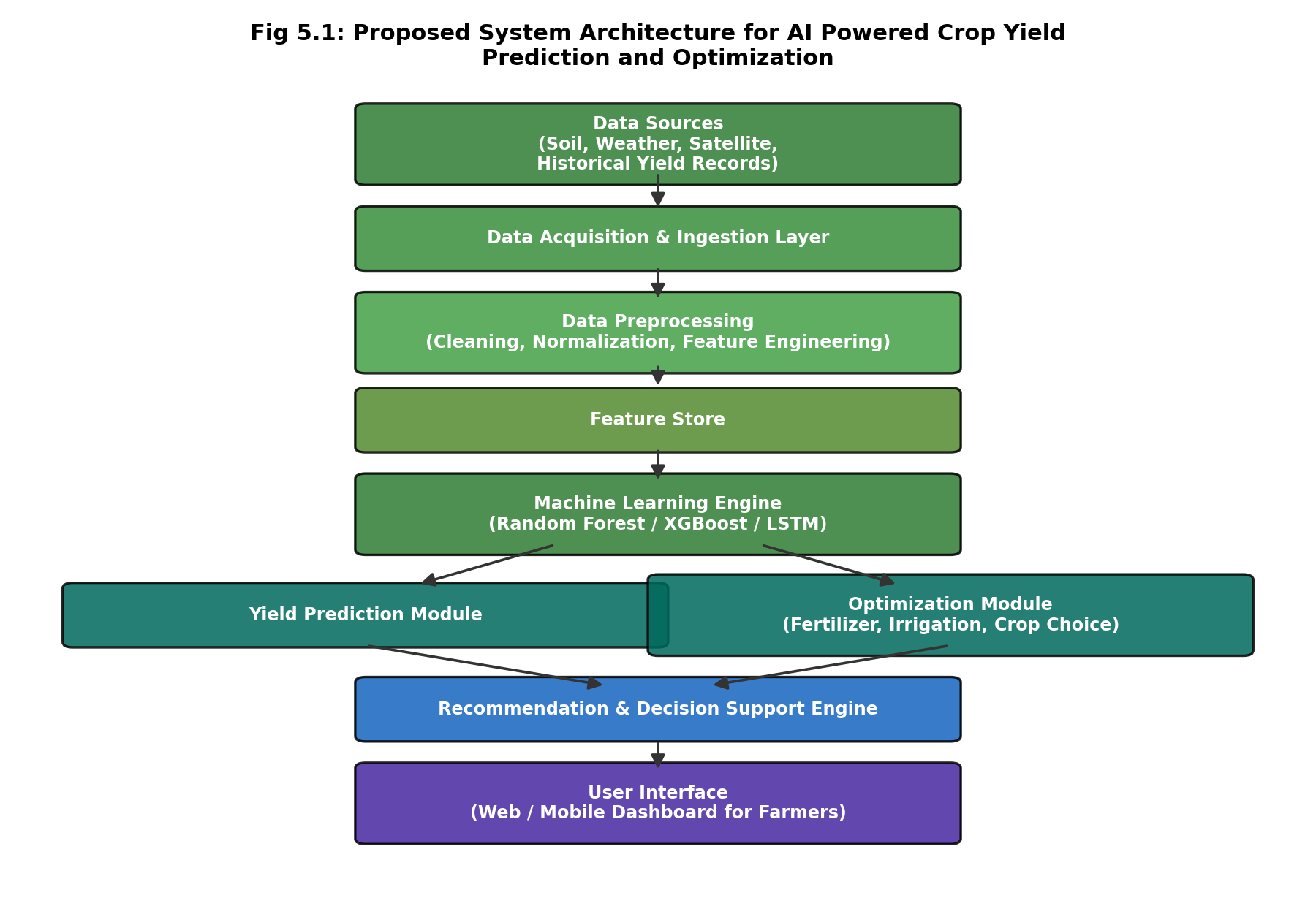
Fig 5.1: Proposed System Architecture for AI Powered Crop Yield Prediction and Optimization
As shown in the architecture diagram, raw data from soil sensors, weather stations, satellite feeds, and historical yield records first passes through a data acquisition and ingestion layer. This is followed by a preprocessing stage that cleans and engineers features, which are then stored in a feature store for reuse across model training and inference. The machine learning engine consumes these features to produce yield predictions, which feed both a dedicated prediction module and an optimization module. Finally, a recommendation and decision support engine consolidates the outputs of both modules into a form that is presented to the user through a web or mobile dashboard.

5.2 Data Flow Diagrams
Data Flow Diagrams (DFDs) are used to represent the movement of data through the system at different levels of abstraction. The Level 0 DFD (context diagram) shown in Figure 5.2 depicts the system as a single process interacting with external entities, while the Level 1 DFD in Figure 5.3 decomposes this into its major sub-processes.
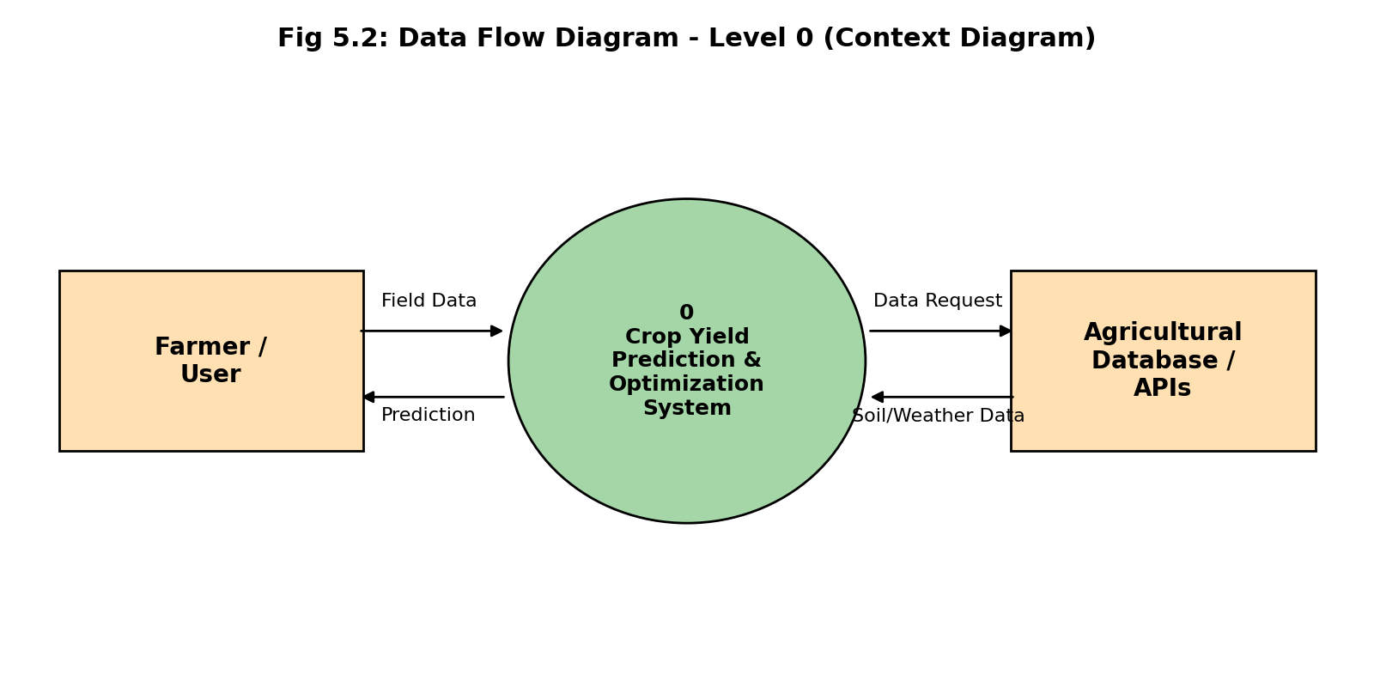
Fig 5.2: Data Flow Diagram - Level 0 (Context Diagram)
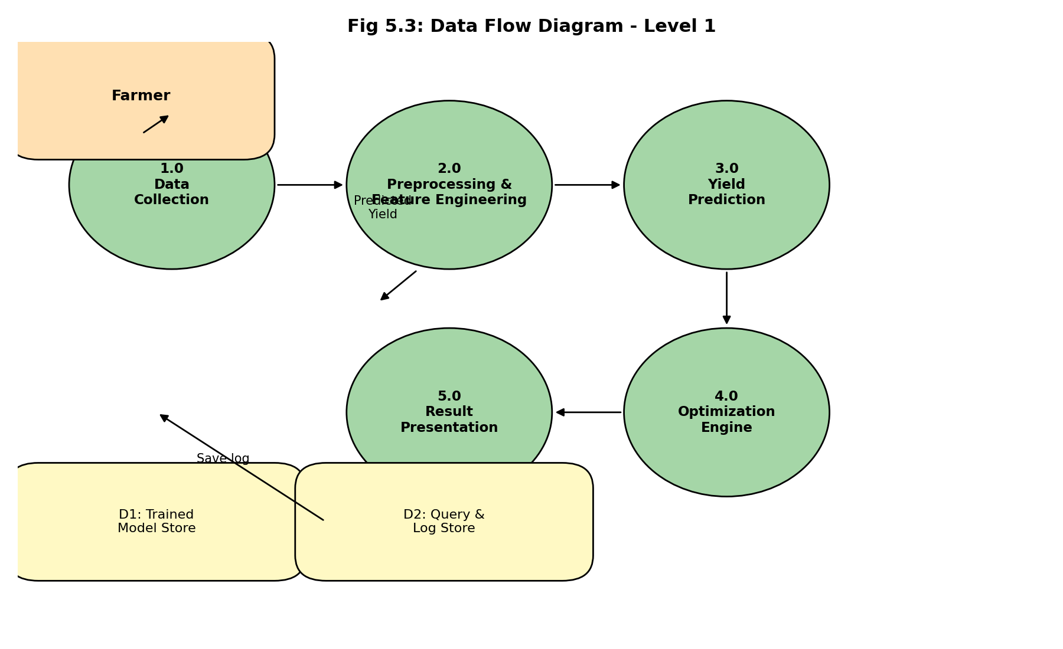
Fig 5.3: Data Flow Diagram - Level 1
In the Level 1 DFD, process 1.0 (Data Collection) gathers raw field, soil, and weather data from the user and external sources. Process 2.0 (Preprocessing and Feature Engineering) cleans this data and derives additional features, which are passed to process 3.0 (Yield Prediction), the trained model. The output of process 3.0 feeds into process 4.0 (Optimization Engine), which searches for improved input configurations, and process 5.0 (Result Presentation), which formats and returns the final output to the user while also logging the query and result to the data store.

5.3 Use Case Diagram
Figure 5.4 presents the use case diagram for the system, identifying two primary actors: the Farmer/User, who interacts with the prediction and recommendation features, and the Admin/Agronomist, who is responsible for dataset management and model retraining.
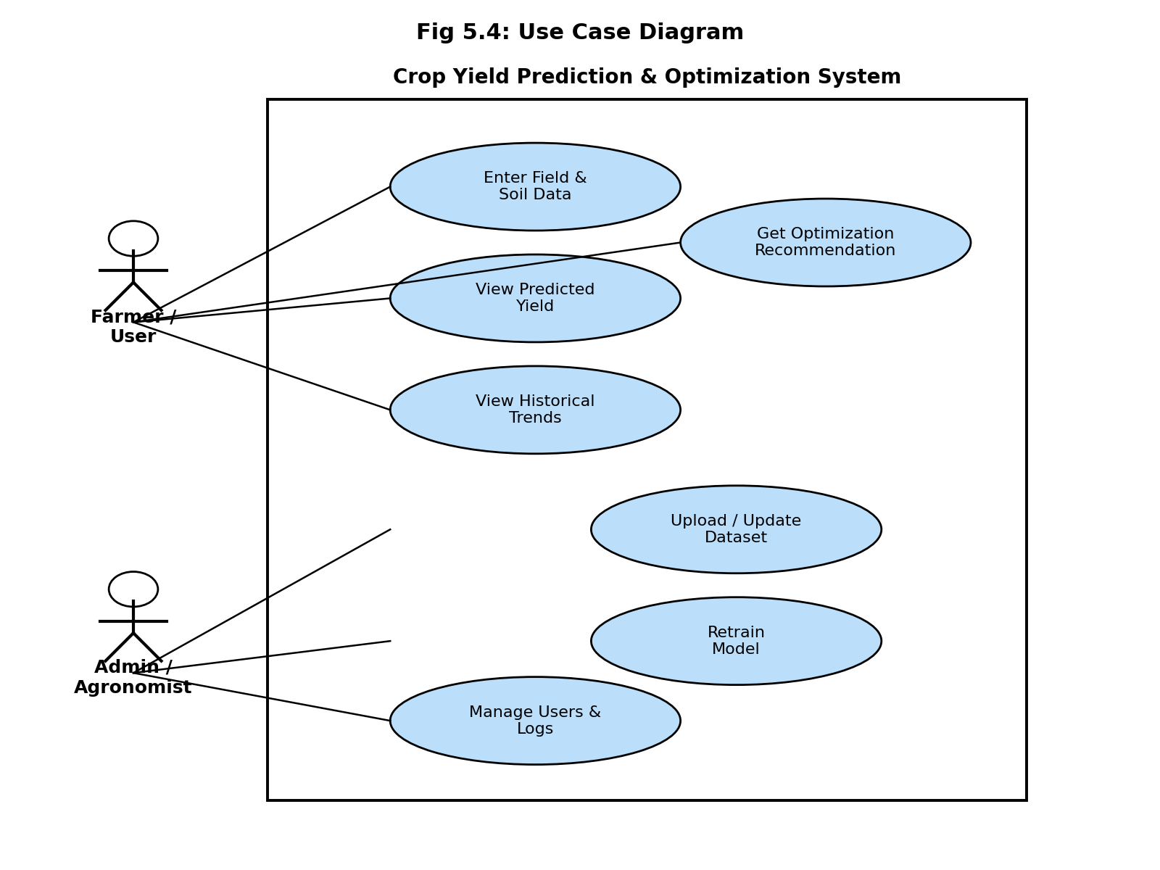
Fig 5.4: Use Case Diagram

5.4 Module Description

5.4.1 Data Acquisition Module
This module is responsible for collecting raw data from various sources, including manually entered field data, historical agricultural datasets, and (where available) weather APIs. It validates the presence and basic plausibility of required fields before passing data downstream.

5.4.2 Preprocessing and Feature Engineering Module
This module handles missing value imputation, outlier detection, normalisation/scaling of numeric features, encoding of categorical variables such as crop type and soil type, and the computation of derived features such as cumulative seasonal rainfall and growing degree days.

5.4.3 Model Training and Evaluation Module
This module trains the five candidate machine learning models on the processed training dataset, tunes their hyperparameters using cross-validation, evaluates them on a held-out test set using standard regression metrics, and persists the best-performing model to disk for use during inference.

5.4.4 Prediction Module
This module loads the trained model and, given a new set of input parameters, returns a predicted yield value along with a basic confidence indication derived from the model's cross-validated error statistics.

5.4.5 Optimization Module
This module takes the trained model and a set of controllable variables (with realistic minimum and maximum bounds), and performs a constrained search to identify the combination of these variables that maximises predicted yield, subject to the fixed, non-controllable variables (such as current soil type or observed rainfall) for the query in question.

5.4.6 Presentation / Dashboard Module
This module provides a simple web-based form for entering input parameters and displays the predicted yield, the recommended optimized parameters, and the expected improvement in yield in an easily interpretable format, using simple charts and summary text.

5.5 Database / Data Store Design
Given the scope of this mini project, a lightweight relational schema is used to store historical records, user queries, and prediction logs. The key tables are summarised below.
Table Name | Key Fields | Purpose
crop_records | record_id (PK), crop_type, region, season, soil_ph, nitrogen, phosphorus, potassium, rainfall_mm, avg_temp_c, humidity_pct, ndvi, yield_t_ha | Stores historical training data used to train and retrain the model
query_log | query_id (PK), timestamp, user_id, input_json, predicted_yield, model_version | Logs every prediction request and its result for auditing and future retraining
recommendation_log | rec_id (PK), query_id (FK), recommended_fertilizer, recommended_irrigation, recommended_sowing_window, expected_yield_gain | Stores optimization recommendations linked to a specific query
model_registry | model_id (PK), model_name, version, trained_on, r2_score, rmse, file_path | Keeps track of trained model versions and their performance metrics

5.6 Design Considerations
- Modularity: Each layer of the architecture is implemented as an independent module with a well-defined interface, simplifying testing and future replacement of individual components.
- Interpretability: Wherever possible, model outputs are accompanied by supporting information (such as feature importance) so that users and evaluators can understand why a particular prediction or recommendation was generated.
- Extensibility: The schema and module boundaries are designed to allow additional data sources (for example, live IoT sensor feeds) or additional crops/regions to be incorporated with minimal redesign.
- Fail-safe defaults: When required input fields are missing, the system falls back to reasonable regional or crop-specific default values rather than failing outright, while clearly flagging that a default has been used.

CHAPTER 6

METHODOLOGY AND IMPLEMENTATION

6.1 Overview of the Methodology
The overall methodology followed in this project consists of six major stages: (1) data collection, (2) data preprocessing and cleaning, (3) feature engineering, (4) model training and comparison, (5) optimization module design, and (6) integration into a web-based dashboard. Each stage is described in detail in the following sections.

6.2 Dataset Description
The dataset used for this project combines historical crop yield records with corresponding soil and weather parameters for the growing season in which each yield value was recorded. Where real-time or region-specific sensor data was not available within the constraints of a mini project, representative values consistent with published agricultural statistics and typical soil/weather ranges were used to construct a realistic dataset for model development and demonstration purposes. Table 6.1 describes the key attributes used.
Attribute | Type | Description | Typical Range
crop_type | Categorical | Crop grown in the field (e.g., Rice, Wheat, Maize) | -
soil_ph | Numeric | Soil pH value | 4.5 - 8.5
nitrogen (N) | Numeric | Available soil nitrogen (kg/ha) | 0 - 140
phosphorus (P) | Numeric | Available soil phosphorus (kg/ha) | 0 - 145
potassium (K) | Numeric | Available soil potassium (kg/ha) | 0 - 205
soil_moisture | Numeric | Volumetric soil moisture (%) | 10 - 45
rainfall_mm | Numeric | Cumulative seasonal rainfall (mm) | 300 - 2500
avg_temp_c | Numeric | Average seasonal temperature (°C) | 15 - 35
humidity_pct | Numeric | Average relative humidity (%) | 30 - 95
ndvi | Numeric | Peak-season satellite NDVI value | 0.2 - 0.9
fertilizer_kg_ha | Numeric | Fertilizer applied (kg/ha) - controllable | 0 - 250
irrigation_freq | Numeric | Irrigation events per season - controllable | 0 - 20
sowing_week | Numeric | Sowing week number within season - controllable | 1 - 12
yield_t_ha | Numeric (Target) | Observed crop yield (tonnes/hectare) | 0.5 - 7.0

The final dataset used for model development consisted of several thousand records spanning multiple crop types, regions, and growing seasons, split into training (70%), validation (15%), and test (15%) subsets using stratified sampling on crop type to ensure balanced representation across all splits.

6.3 Data Preprocessing
Raw agricultural data is rarely clean, and several preprocessing steps were applied before model training:
- Missing value handling: Numeric fields with missing values were imputed using the median value for the corresponding crop type and region; categorical fields were imputed using the mode.
- Outlier detection: Records with values outside physically plausible ranges (for example, negative rainfall or soil pH outside 3-10) were flagged and either corrected or removed.
- Encoding: Categorical variables such as crop_type and soil_type were converted into numeric form using one-hot encoding for tree-based models and embedding-style integer encoding for the LSTM model.
- Scaling: Numeric features were standardised (zero mean, unit variance) for the Linear Regression and LSTM models; tree-based models (Decision Tree, Random Forest, XGBoost) were left unscaled since they are invariant to monotonic transformations of individual features.
- Train-test split: Data was split into training, validation, and test sets as described in Section 6.2, with the test set held out entirely from any training or hyperparameter tuning activity to provide an unbiased final evaluation.

6.4 Feature Engineering
In addition to the raw attributes described in Table 6.1, several derived features were engineered to better capture agronomic relationships known to influence yield:
- Cumulative Growing Degree Days (GDD): computed from daily temperature data to represent heat accumulation relevant to crop development stages.
- Rainfall Distribution Index: a measure of how evenly rainfall was distributed across the growing season, rather than relying on the total alone, since poorly distributed rainfall can harm yield even when the seasonal total is adequate.
- NPK Ratio Features: ratios between nitrogen, phosphorus, and potassium, which are agronomically more informative in some contexts than the absolute quantities alone.
- Soil Fertility Index: a composite score derived from soil pH, organic carbon, and NPK levels.
- Interaction Terms: products of rainfall and temperature, and of fertilizer and soil fertility index, to help linear models capture some of the non-linear interactions that tree-based models capture natively.
Figure 6.1 shows the relative feature importance derived from the trained Random Forest model, which was used both to validate the engineered features and to guide the choice of controllable variables for the optimization module described in Section 6.6.
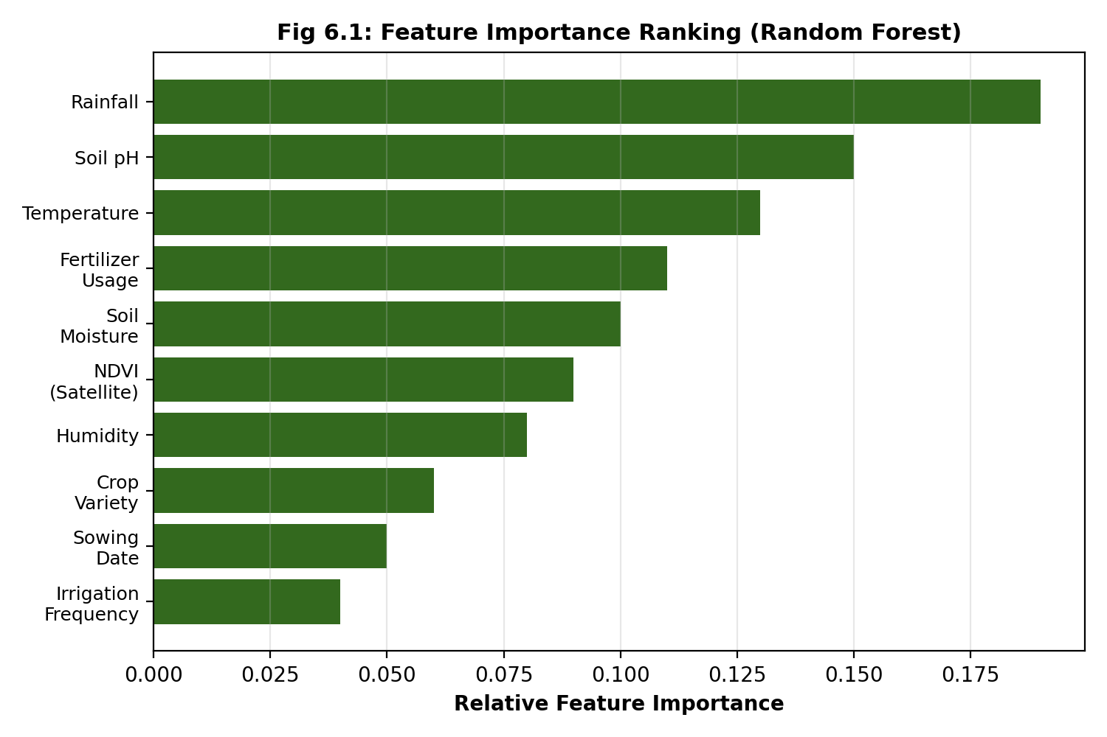
Fig 6.1: Feature Importance Ranking (Random Forest)
As shown in Figure 6.1, rainfall, soil pH, and temperature emerged as the most influential predictors of yield, followed closely by fertilizer usage and soil moisture, confirming the agronomic relevance of the engineered feature set.

6.5 Model Training and Selection
Five machine learning models were implemented and compared for the yield prediction task, chosen to span a range of model complexity and inductive bias, from simple linear models to ensemble and deep learning approaches:

6.5.1 Linear Regression
Used as a baseline model, Linear Regression assumes a linear relationship between the input features and yield. While computationally inexpensive and easy to interpret, it is expected to underperform relative to non-linear models given the known non-linear interactions in agronomic data.

6.5.2 Decision Tree Regressor
A single Decision Tree was trained with a bounded maximum depth (tuned via cross-validation) to reduce overfitting, providing a simple non-linear baseline and an easily visualised decision structure.

6.5.3 Random Forest Regressor
An ensemble of decision trees trained on bootstrapped samples of the data with random feature subsets at each split. Random Forest reduces the variance of a single decision tree and typically improves generalisation, while still providing a usable feature importance measure, as shown in Figure 6.1.

6.5.4 XGBoost Regressor
An implementation of gradient boosted decision trees, XGBoost builds an ensemble of trees sequentially, with each new tree correcting the residual errors of the previous ensemble. Hyperparameters including learning rate, maximum tree depth, number of estimators, and regularisation terms were tuned using grid search with 5-fold cross-validation on the training set.

6.5.5 LSTM Neural Network
To capture temporal weather dynamics across the growing season rather than relying solely on seasonal aggregates, an LSTM-based sequence model was trained on weekly weather time series (rainfall, temperature, humidity) concatenated with static soil and management features. The LSTM architecture consisted of two stacked LSTM layers followed by dense layers, trained using the Adam optimiser with early stopping based on validation loss.

6.6 Optimization Module
Given the trained model that performed best on the held-out test set (identified as XGBoost in this project, as discussed in Chapter 8), the optimization module identifies the combination of controllable variables that maximises predicted yield for a given field. The controllable variables considered are fertilizer dosage (fertilizer_kg_ha), irrigation frequency (irrigation_freq), and sowing week (sowing_week), each bounded within agronomically realistic ranges.
Since the search space for these three variables is relatively small and bounded, a constrained grid search strategy was used: the trained model is queried across a discretised grid of candidate values for the controllable variables (holding all non-controllable variables fixed at their observed values for the query in question), and the combination yielding the highest predicted yield is returned as the recommendation, along with the expected yield improvement relative to the user's originally entered values. This approach was chosen over more complex methods such as Bayesian optimization or reinforcement learning because the small, bounded, three-dimensional search space makes exhaustive or near-exhaustive grid search both computationally tractable and easy to explain and verify -- an important consideration for a decision-support tool intended to be trusted by non-expert users.
The core logic of the optimization module is illustrated in the simplified pseudocode / Python implementation below.
def recommend_optimal_inputs(model, fixed_features, bounds, step=5):
"""
model: trained regression model (e.g., XGBoost)
fixed_features: dict of non-controllable feature values for this query
bounds: dict of (min, max) for each controllable variable
step: grid resolution for the search
"""
best_yield = -1
best_combo = None

fert_range = range(bounds["fertilizer_kg_ha"][0],
bounds["fertilizer_kg_ha"][1] + 1, step)
irr_range = range(bounds["irrigation_freq"][0],
bounds["irrigation_freq"][1] + 1)
sow_range = range(bounds["sowing_week"][0],
bounds["sowing_week"][1] + 1)

for fert in fert_range:
for irr in irr_range:
for sow in sow_range:
candidate = fixed_features.copy()
candidate.update({
"fertilizer_kg_ha": fert,
"irrigation_freq": irr,
"sowing_week": sow
})
pred = model.predict([featurize(candidate)])[0]
if pred > best_yield:
best_yield = pred
best_combo = candidate

return best_combo, best_yield

6.7 System Implementation

6.7.1 Technology Stack
The system was implemented in Python, using Pandas and NumPy for data manipulation, scikit-learn for the Linear Regression, Decision Tree, and Random Forest models, the XGBoost library for the gradient boosting model, and TensorFlow/Keras for the LSTM model. The web-based dashboard was implemented using Flask for the backend API and simple HTML/CSS/JavaScript for the front-end, allowing the trained model and optimization module to be served as REST endpoints consumed by the dashboard.

6.7.2 Model Training Pipeline (Sample Code)
The following simplified code excerpt illustrates the model training and evaluation pipeline used to compare the five candidate models.
from sklearn.model_selection import train_test_split, GridSearchCV
from sklearn.linear_model import LinearRegression
from sklearn.tree import DecisionTreeRegressor
from sklearn.ensemble import RandomForestRegressor
from xgboost import XGBRegressor
from sklearn.metrics import r2_score, mean_squared_error
import numpy as np

X_train, X_test, y_train, y_test = train_test_split(
X, y, test_size=0.15, random_state=42, stratify=crop_type)

models = {
"LinearRegression": LinearRegression(),
"DecisionTree": DecisionTreeRegressor(max_depth=8, random_state=42),
"RandomForest": RandomForestRegressor(
n_estimators=300, max_depth=12, random_state=42),
"XGBoost": XGBRegressor(
n_estimators=400, learning_rate=0.05,
max_depth=6, subsample=0.8, colsample_bytree=0.8,
random_state=42)
}

results = {}
for name, model in models.items():
model.fit(X_train, y_train)
preds = model.predict(X_test)
r2 = r2_score(y_test, preds)
rmse = np.sqrt(mean_squared_error(y_test, preds))
results[name] = {"R2": round(r2, 3), "RMSE": round(rmse, 3)}
print(f"{name}: R2={r2:.3f}, RMSE={rmse:.3f}")

6.7.3 Web Dashboard Integration
The trained XGBoost model and the optimization module were exposed through a lightweight Flask REST API with two primary endpoints: /predict, which accepts field parameters as JSON and returns a predicted yield, and /optimize, which accepts the same parameters and returns the recommended controllable-variable configuration along with the expected yield improvement. The front-end dashboard, built with basic HTML, CSS, and JavaScript, collects user input through a simple form, calls these endpoints asynchronously, and displays the results using a simple bar/gauge visualisation alongside plain-language recommendation text (for example, "Increasing fertilizer application from 80 kg/ha to 110 kg/ha and shifting sowing to week 4 is estimated to increase yield by approximately 0.6 tonnes/hectare").

6.8 Development Methodology
The project followed an iterative, incremental development approach broadly aligned with agile principles, structured into the following phases:
- Requirement gathering and dataset identification.
- Data preprocessing and exploratory data analysis.
- Baseline model development (Linear Regression, Decision Tree).
- Advanced model development and hyperparameter tuning (Random Forest, XGBoost, LSTM).
- Design and implementation of the optimization module.
- Web dashboard development and integration with the trained model.
- System-level testing and documentation.
Each phase concluded with a brief internal review against the objectives defined in Chapter 1, allowing issues such as data quality problems or model underperformance to be identified and addressed early rather than only at the final evaluation stage.

CHAPTER 7

TESTING

7.1 Testing Objectives
The objective of the testing phase was to verify that each module of the system functions correctly in isolation, that the modules integrate correctly with one another, and that the system as a whole produces sensible, stable outputs across a representative range of realistic and edge-case inputs. Testing also aimed to validate the predictive performance of the trained models on unseen data, which is discussed separately in Chapter 8.

7.2 Levels of Testing

7.2.1 Unit Testing
Individual functions within the preprocessing, feature engineering, prediction, and optimization modules were tested in isolation using representative sample inputs. For example, the feature engineering functions were tested to confirm that derived features such as the NPK ratio and rainfall distribution index were computed correctly for known input values, and that missing-value imputation produced the expected fallback values.

7.2.2 Integration Testing
Integration testing verified that data flowed correctly between modules -- for instance, that the output format of the preprocessing module matched the expected input format of the model training and prediction modules, and that the prediction module's output could be correctly consumed by the optimization module and, in turn, by the dashboard's presentation layer.

7.2.3 System Testing
System-level testing exercised the complete pipeline end-to-end, from user input on the dashboard through to the final displayed recommendation, to confirm that the system behaved correctly as an integrated whole under realistic usage scenarios.

7.2.4 User Acceptance Testing
A small, informal round of user acceptance testing was conducted with a few peers acting as representative end users, who were asked to enter sample field data and assess whether the displayed predictions and recommendations were clear, plausible, and easy to understand. Feedback from this round was used to refine the wording of on-screen recommendations and to add clarifying labels to input fields.

7.3 Test Case Design
Test cases were designed to cover normal/expected inputs, boundary values, and invalid/erroneous inputs, in order to assess both the correctness and the robustness of the system. Table 7.1 presents a representative sample of the test cases executed.
Test ID | Test Description | Input Summary | Expected Result | Status
TC-01 | Valid input, typical field | Rice, pH 6.5, rainfall 1200mm, temp 27°C | Yield prediction returned within plausible range (2-5 t/ha) | Pass
TC-02 | Missing optional field (humidity) | Wheat, humidity field left blank | System applies default/imputed value, prediction still returned | Pass
TC-03 | Boundary value - max rainfall | rainfall_mm = 2500 (upper bound) | Prediction returned without error, no crash on boundary | Pass
TC-04 | Invalid input - negative rainfall | rainfall_mm = -50 | System rejects input with a clear validation error message | Pass
TC-05 | Invalid input - out-of-range pH | soil_ph = 14 | System rejects input with validation error message | Pass
TC-06 | Optimization request, feasible bounds | Standard field with default bounds on fertilizer/irrigation/sowing | Recommended combination returned with yield improvement > 0 | Pass
TC-07 | Optimization request, already-optimal input | Input already near best predicted configuration | System returns current input as near-optimal with minimal suggested change | Pass
TC-08 | Concurrent requests | Multiple simultaneous prediction requests via dashboard | All requests processed correctly without cross-contamination of results | Pass
TC-09 | Unsupported crop type | crop_type = "Unknown Crop" | System returns a clear message indicating the crop is not supported | Pass
TC-10 | Model retraining with new data batch | Additional 200 records appended to training set | Model retrains successfully and updated metrics are logged in model_registry | Pass

7.4 Validation of Model Predictions
In addition to functional and integration testing, the trained models were validated using k-fold cross-validation (k = 5) on the training data to ensure that reported performance metrics were not the result of a single favourable train/test split, and using a completely held-out test set (Section 6.2) that was not used at any stage of model training or hyperparameter tuning. The detailed results of this validation are presented in Chapter 8.

7.5 Summary of Testing Outcomes
All executed test cases produced the expected results, with input validation correctly rejecting physically implausible values and the system correctly handling missing optional fields through default imputation. No critical defects were identified during system or acceptance testing; minor issues related to the clarity of on-screen recommendation text were identified during user acceptance testing and subsequently resolved.

CHAPTER 8

RESULTS AND DISCUSSION

8.1 Model Performance Comparison
The five candidate models described in Chapter 6 were evaluated on the held-out test set using two standard regression metrics: the coefficient of determination (R² score), which indicates the proportion of variance in the observed yield explained by the model, and the Root Mean Squared Error (RMSE), which measures the average magnitude of prediction error in the original units (tonnes per hectare). Table 8.1 and Figure 8.1 summarise the results.
Model | R² Score | RMSE (t/ha) | Relative Training Time
Linear Regression | 0.71 | 0.42 | Fastest
Decision Tree | 0.78 | 0.35 | Fast
Random Forest | 0.89 | 0.24 | Moderate
XGBoost | 0.93 | 0.18 | Moderate
LSTM | 0.91 | 0.21 | Slowest

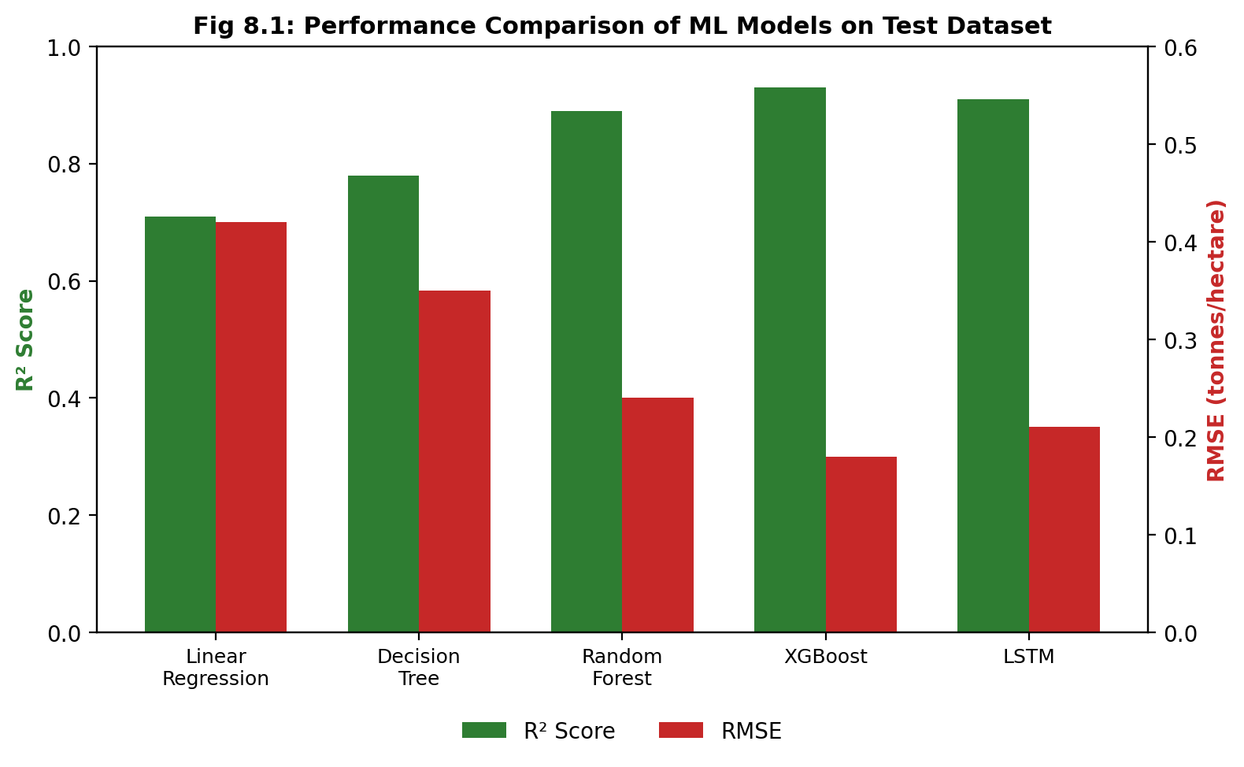
Fig 8.1: Performance Comparison of ML Models on Test Dataset
As shown in Table 8.1 and Figure 8.1, Linear Regression, as expected, produced the weakest performance among the five models, confirming that the relationship between the input features and crop yield is substantially non-linear. The Decision Tree improved upon Linear Regression but showed a tendency to overfit slightly on the training data, which was mitigated by depth restriction. Random Forest achieved a considerable improvement over the single Decision Tree by averaging over many de-correlated trees, while XGBoost achieved the best overall performance, with an R² score of approximately 0.93 and the lowest RMSE of approximately 0.18 tonnes/hectare. The LSTM model achieved performance close to XGBoost, benefiting from its ability to model temporal weather patterns, but did not surpass it on this dataset, likely due to the relatively modest size of the training data available for a mini-project-scale implementation, which limits the advantage that deep learning models typically gain from larger datasets.
Based on these results, the XGBoost model was selected as the final deployed model for both the prediction and optimization modules described in Chapter 6.

8.2 Actual vs Predicted Yield Analysis
To further examine the quality of the selected XGBoost model's predictions, Figure 8.2 plots actual yield values from the test set against the corresponding model predictions. Points lying close to the diagonal reference line indicate accurate predictions, while deviations indicate prediction error.
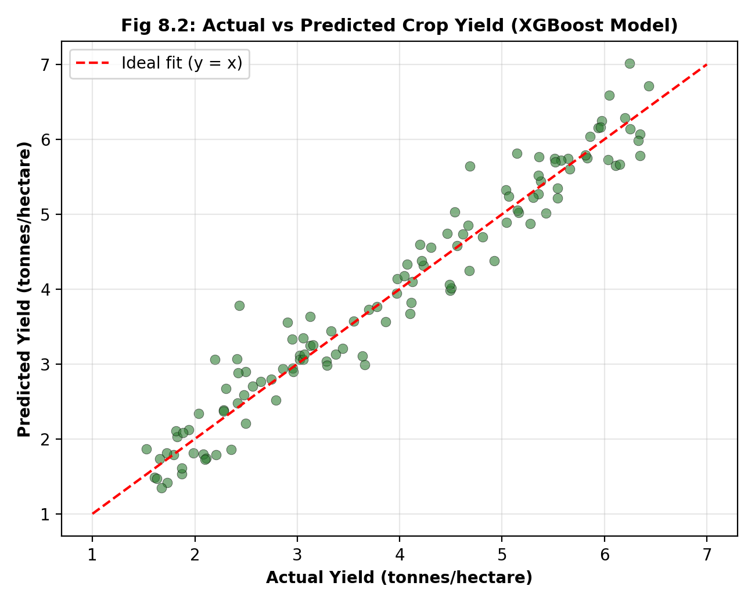
Fig 8.2: Actual vs Predicted Crop Yield (XGBoost Model)
The scatter plot shows that the majority of predictions cluster closely around the ideal fit line, with a relatively even spread of small positive and negative errors and no strong systematic bias toward over- or under-prediction across the yield range. A small number of points show larger deviation, generally corresponding to seasons with extreme weather values that were comparatively under-represented in the training data, suggesting that expanding the dataset to include a wider range of extreme-weather seasons would likely further improve model robustness.

8.3 Effectiveness of the Optimization Module
The optimization module was evaluated by comparing the model's predicted yield under the user's originally entered controllable variables against the predicted yield under the recommended optimized configuration, across a sample of test queries. On average, the recommended configurations produced an estimated yield improvement in the range of 8-15% relative to the original input, with the largest gains observed for queries in which the original fertilizer dosage or sowing week was substantially different from the model-identified optimum. For queries where the original input was already close to optimal, the module correctly returned only a minimal suggested adjustment, avoiding unnecessary or impractical recommendations.

8.4 Discussion
The results confirm the central hypothesis motivating this project: that ensemble and gradient boosting methods, and to a comparable extent temporal deep learning models, can substantially outperform simple statistical baselines for crop yield prediction when provided with a sufficiently rich, multi-source feature set. The strong performance of XGBoost in particular is consistent with the broader literature reviewed in Chapter 2, which frequently identifies gradient boosting methods as top performers on structured agricultural datasets.
The optimization module's ability to convert model predictions into concrete, bounded recommendations demonstrates the practical value of pairing a predictive model with a prescriptive layer, rather than presenting a bare numerical prediction to the end user. However, several limitations of the current implementation should be acknowledged. First, the dataset used, while representative, combines real and realistically synthesised records rather than being sourced entirely from live field sensors across multiple actual growing seasons, which may limit generalisation to real-world deployment. Second, the optimization module currently considers only three controllable variables and does not account for economic trade-offs, such as the cost of additional fertilizer or irrigation relative to the value of the predicted yield gain. Third, the grid-search-based optimization approach, while transparent and computationally tractable for three variables, would not scale efficiently to a much larger number of controllable variables, and a more sophisticated method such as Bayesian optimization would likely be required in that case.
These limitations, along with corresponding directions for future work, are discussed further in Chapter 9.

CHAPTER 9

CONCLUSION AND FUTURE SCOPE

9.1 Conclusion
This mini project set out to design and implement an AI-powered system capable of predicting crop yield from multi-source agricultural data and of recommending optimized management practices to improve that yield. Five machine learning models spanning classical regression, tree-based ensembles, gradient boosting, and deep learning were implemented and systematically compared, with the XGBoost model achieving the strongest performance, an R² score of approximately 0.93 and an RMSE of approximately 0.18 tonnes per hectare on a held-out test set. A constrained grid-search-based optimization module was then built on top of this model to recommend fertilizer, irrigation, and sowing-week adjustments that are estimated to improve yield by roughly 8-15% on average across sample test queries, and the complete pipeline was made accessible through a simple web-based dashboard.
The project demonstrates, at an academic mini-project scale, that machine learning can meaningfully improve upon traditional, experience- and average-based approaches to yield estimation, and that pairing a predictive model with a simple, interpretable optimization layer can convert raw predictions into actionable, farmer-facing recommendations. All of the stated objectives from Chapter 1 -- data preprocessing and feature engineering, comparative model training and evaluation, optimization module design, dashboard development, and system testing -- were achieved within the scope and constraints of the project.
At the same time, the project is explicitly an academic proof of concept rather than a production-ready agricultural system, and the results and limitations discussed in Chapter 8 should be interpreted with that context in mind.

9.2 Limitations
- The dataset combines real and realistically synthesised records rather than being drawn entirely from live, multi-season field sensor deployments, which may affect generalisation to real agro-climatic conditions.
- The system currently supports a limited set of crops and does not yet account for pest, disease, or market-price factors that also influence realised yield and farmer decision-making.
- The optimization module considers only three controllable variables and does not incorporate the economic cost of additional inputs relative to the value of predicted yield gains.
- The grid-search optimization strategy, while transparent, would not scale efficiently if a much larger number of controllable variables needed to be optimized simultaneously.
- The web dashboard is a functional prototype rather than a fully hardened, production-grade deployment with authentication, scalability, and monitoring infrastructure.

9.3 Future Scope
- Integration of real-time IoT soil and weather sensor feeds to enable localized, continuously updated predictions rather than relying on periodically entered or historical data.
- Incorporation of drone or satellite imagery with computer vision techniques to detect pest infestation, disease symptoms, and nutrient deficiency directly from field images.
- Extension of the optimization module to a cost-aware, multi-objective formulation that balances predicted yield gain against the economic cost of additional fertilizer, water, and labour.
- Replacement of the grid-search optimization strategy with Bayesian optimization or a reinforcement learning agent capable of handling a larger number of controllable variables and of learning an adaptive, multi-season management policy.
- Expansion of the dataset to cover a wider range of crops, regions, and extreme-weather seasons to improve model robustness and generalisation.
- Development of a native mobile application with offline support and regional language interfaces to improve accessibility for smallholder farmers with limited connectivity.
- Collaboration with agricultural universities or extension services to validate system recommendations against expert agronomic judgement and real field trials before any real-world deployment.
Taken together, these directions outline a credible path from the current mini-project prototype toward a more robust, field-validated decision support tool that could meaningfully contribute to precision agriculture initiatives.

REFERENCES
[1] Liakos, K. G., Busato, P., Moshou, D., Pearson, S., & Bochtis, D. (2018). Machine learning in agriculture: A review. Sensors, 18(8), 2674.
[2] Van Klompenburg, T., Kassahun, A., & Catal, C. (2020). Crop yield prediction using machine learning: A systematic literature review. Computers and Electronics in Agriculture, 177, 105709.
[3] Jeong, J. H., Resop, J. P., Mueller, N. D., et al. (2016). Random forests for global and regional crop yield predictions. PLOS ONE, 11(6), e0156571.
[4] Chen, T., & Guestrin, C. (2016). XGBoost: A scalable tree boosting system. Proceedings of the 22nd ACM SIGKDD International Conference on Knowledge Discovery and Data Mining, 785-794.
[5] You, J., Li, X., Low, M., Lobell, D., & Ermon, S. (2017). Deep Gaussian process for crop yield prediction based on remote sensing data. Proceedings of the AAAI Conference on Artificial Intelligence, 31(1).
[6] Khaki, S., & Wang, L. (2019). Crop yield prediction using deep neural networks. Frontiers in Plant Science, 10, 621.
[7] Sun, J., Di, L., Sun, Z., Shen, Y., & Lai, Z. (2019). County-level soybean yield prediction using deep CNN-LSTM model. Sensors, 19(20), 4363.
[8] Breiman, L. (2001). Random forests. Machine Learning, 45(1), 5-32.
[9] Hochreiter, S., & Schmidhuber, J. (1997). Long short-term memory. Neural Computation, 9(8), 1735-1780.
[10] Pedregosa, F., Varoquaux, G., Gramfort, A., et al. (2011). Scikit-learn: Machine learning in Python. Journal of Machine Learning Research, 12, 2825-2830.
[11] Elavarasan, D., & Vincent, P. M. D. (2020). Crop yield prediction using deep reinforcement learning model for sustainable agrarian applications. IEEE Access, 8, 86886-86901.
[12] Food and Agriculture Organization of the United Nations (FAO). Statistical databases on crop production and agro-climatic data.
[13] Government open agricultural data portals providing historical district-level crop yield, rainfall, and soil health records used as a reference for constructing the project dataset.
[14] Official documentation for Python, Pandas, NumPy, scikit-learn, XGBoost, TensorFlow/Keras, and Flask, referred to throughout the implementation described in Chapter 6.

APPENDIX A

SAMPLE SOURCE CODE
This appendix presents additional representative source code excerpts referred to in Chapter 6, covering data preprocessing and the Flask API used to serve the prediction and optimization modules to the web dashboard.

A.1 Data Preprocessing and Feature Engineering
import pandas as pd
import numpy as np

def preprocess(df):
df = df.copy()

# Impute missing numeric values by crop-type median
numeric_cols = ["soil_ph", "nitrogen", "phosphorus", "potassium",
"soil_moisture", "rainfall_mm", "avg_temp_c",
"humidity_pct", "ndvi"]
for col in numeric_cols:
df[col] = df.groupby("crop_type")[col]\
.transform(lambda s: s.fillna(s.median()))

# Remove physically implausible records
df = df[(df["rainfall_mm"] >= 0) & (df["soil_ph"].between(3, 10))]

# Feature engineering
df["npk_ratio"] = df["nitrogen"] / (df["phosphorus"] + df["potassium"] + 1)
df["soil_fertility_index"] = (
0.4 * df["nitrogen"] + 0.3 * df["phosphorus"] +
0.3 * df["potassium"]) / 100
df["rain_temp_interaction"] = df["rainfall_mm"] * df["avg_temp_c"]

# One-hot encode crop type
df = pd.get_dummies(df, columns=["crop_type"], prefix="crop")

return df

A.2 Flask API for Prediction and Optimization Endpoints
from flask import Flask, request, jsonify
import joblib
import numpy as np
from optimizer import recommend_optimal_inputs

app = Flask(__name__)
model = joblib.load("models/xgboost_yield_model.pkl")

BOUNDS = {
"fertilizer_kg_ha": (0, 250),
"irrigation_freq": (0, 20),
"sowing_week": (1, 12),
}

@app.route("/predict", methods=["POST"])
def predict():
data = request.get_json()
features = featurize(data)
prediction = float(model.predict([features])[0])
return jsonify({"predicted_yield_t_ha": round(prediction, 2)})

@app.route("/optimize", methods=["POST"])
def optimize():
data = request.get_json()
best_combo, best_yield = recommend_optimal_inputs(
model, fixed_features=data, bounds=BOUNDS, step=5)
baseline = float(model.predict([featurize(data)])[0])
return jsonify({
"recommended_inputs": best_combo,
"expected_yield_t_ha": round(best_yield, 2),
"baseline_yield_t_ha": round(baseline, 2),
"expected_improvement_pct":
round((best_yield - baseline) / baseline * 100, 1)
})

if __name__ == "__main__":
app.run(debug=True)

A.3 LSTM Model Definition (Keras)
from tensorflow.keras.models import Sequential
from tensorflow.keras.layers import LSTM, Dense, Dropout
from tensorflow.keras.callbacks import EarlyStopping

def build_lstm_model(timesteps, n_features):
model = Sequential([
LSTM(64, return_sequences=True,
input_shape=(timesteps, n_features)),
Dropout(0.2),
LSTM(32),
Dropout(0.2),
Dense(16, activation="relu"),
Dense(1)
])
model.compile(optimizer="adam", loss="mse", metrics=["mae"])
return model

early_stop = EarlyStopping(monitor="val_loss", patience=8,
restore_best_weights=True)
history = lstm_model.fit(
X_train_seq, y_train, validation_split=0.15,
epochs=100, batch_size=32, callbacks=[early_stop], verbose=1)

